Klasa 1 23.04
Lesson
Topic: Where’s my skateboard? – Gdzie jest moja deskorolka?

Songs (piosenki) :
1) Prepositions of place IN, ON, UNDER : https://www.youtube.com/watch?v=dupaTS-c8Xc
2) Where’s my skateboard? https://www.youtube.com/watch?v=zP8CpwcEgO4
Exercises (ćwiczenia)
1,2/62

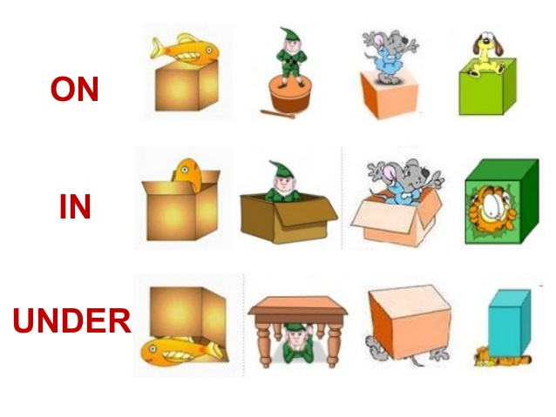
- *Toys song – piosenka o zabawkach* : https://www.youtube.com/watch?v=BoJBeGUHGv8
- Game (gra): https://wordwall.net/pl/resource/1104415/angielski/tiger-1-unit-6

